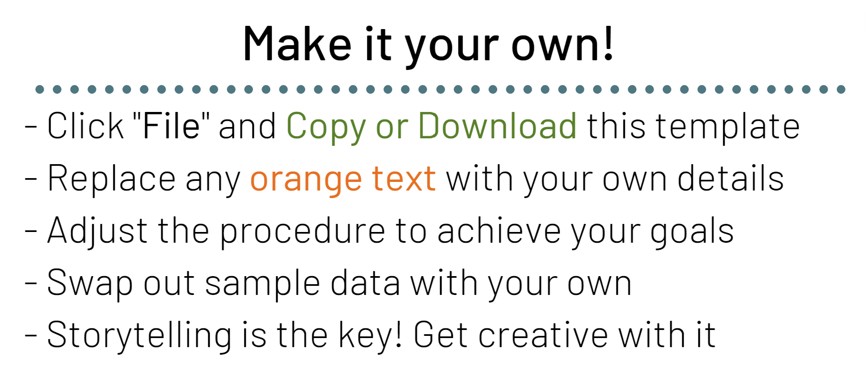
Learn more about IP3 Strategy here

(Name)
Your name, Class of ____
School, School District, City

1. Impact Design

Impact Statement -

Community Alignment
Group | Goal/Action

Procedure - Steps for implementation!

2. Impact Data Tracking - Quantify your impact!

3. Impact Storytelling - Share your data with who needs to know! See more tips
Think on 4 scales of stakeholders… Family, School, Community, and Aligned Groups

Stakeholder | Interests | Approach
Family —
School —
Community —
Aligned Groups —

Add your project to our website under “Submit your Impact”! Contribute to collective impact…

